Task 01:

Create a java program to retrieve dynamodb ttable records and display..

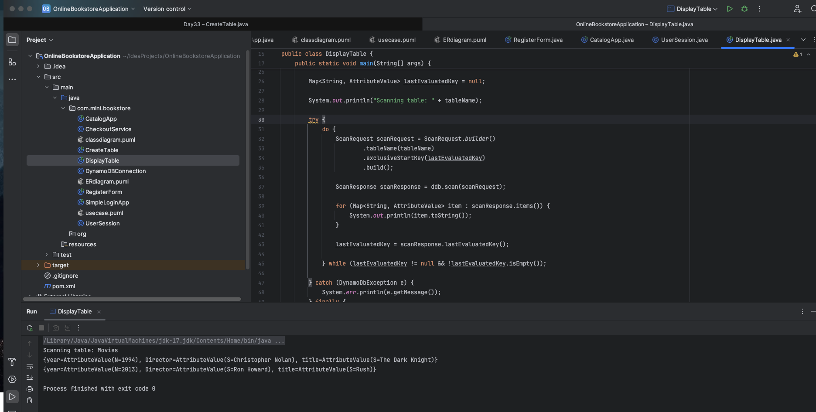

TASK 02:

Create a java program to create a table and insert 2 items .. the NOSQl workbench we should be able to see the table updated.

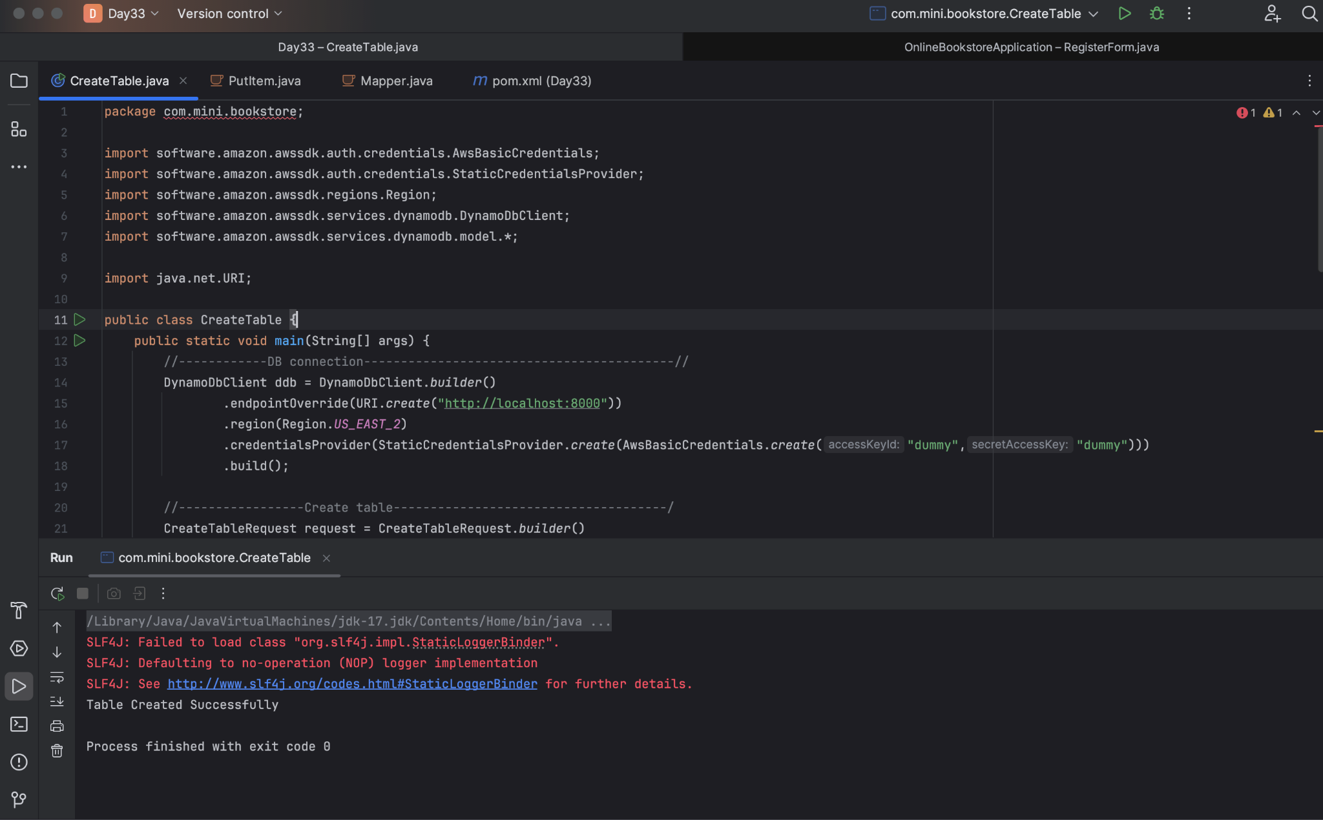

Task 03:

What key features of DynamoDB?

- Fully Managed and serverless.
- Flexible
- Scalable
- Backup & Restore

Task 04:

What are the advantages and disadvantages of DynamoDB?

Advantages:
- High performance at scale
- Fully managed and serverless.
- Scalable
- Secured
- Flexible data model
- Backup and Restore

Disadvantages:

- Limited querying capability
- No native support for relational features
- Cost spike with high read and write volume
- Item size limit
- High learning curve.

Task 05:

Where do we use DynamoDB (use cases of DynamoDB)

Industry | Use Case Example
Gaming | Player stats, matchmaking
Transportation | Ride tracking, driver availability
Retail | Inventory, order processing
Healthcare | Patient records, device telemetry
Education | Progress tracking, quiz history

Task 06:

What is DynamoDBMapper?

The DynamoDBMapper class is the entry point to Amazon DynamoDB. It provides access to a DynamoDB endpoint and enables you to access your data in various tables. It also enables you to perform various create, read, update, and delete (CRUD) operations on items, and run queries and scans against tables. This class provides the following methods for working with DynamoDB.

Task 07:

What are DynamoDb Projections?

In DynamoDB, projections are a way to control which attributes are included in a secondary index or returned in a query/scan operation. They help optimize performance, reduce storage costs, and limit the data retrieved to only what your application needs.

1. Index Projections (Global or Local Secondary Indexes)
2. Projection Expressions (Query/Scan Operations)

Task 08:

How can you say that DYnamoDB prevents data loss?

DynamoDB is designed with resilience and durability at its core, and it employs multiple strategies to prevent data loss—even in the face of hardware failures, network issues, or human error. Here's how it keeps your data safe:

1. Multi-AZ Replication
Every piece of data in DynamoDB is automatically replicated across multiple Availability Zones within an AWS Region. This means:
- If one data center fails, your data is still available from others.
- Replication is synchronous and ensures high durability.

2. Point-in-Time Recovery (PITR)
DynamoDB offers continuous backups that let you restore your table to any second within the last 35 days.
- Protects against accidental deletes or overwrites.
- No need to manually schedule backups.

3. On-Demand Backups
You can create full backups of your tables at any time, without impacting performance.
- Useful for long-term retention or compliance needs.
4. Global Tables
For mission-critical apps, DynamoDB supports multi-region replication using Global Tables.
- Ensures data availability even if an entire region goes down.
- Keeps tables in sync across continents.

5. Conditional Writes
To prevent accidental overwrites, DynamoDB supports conditional expressions:
java
PutItemRequest.builder()
.conditionExpression("attribute_not_exists(EmployeeId)")

This ensures that an item is only written if it doesn’t already exist—protecting against unintended data loss due to overwrites.

6. DynamoDB Streams
Streams capture every change to your table and retain it for 24 hours.
- Enables recovery workflows or auditing.
- Can trigger AWS Lambda for custom backup or alerting logic.

7. Solid-State Storage
All data is stored on SSD-backed infrastructure, which is more reliable and faster than traditional disks
Task 09:

What is in-place atomic updates means ? does dynamoaDB supports?

In-place atomic updates refer to modifying a specific attribute of a database item directly, without needing to:
- Read the item first
- Modify it in your application
- Write it back
And atomic means the update is all-or-nothing—it either fully succeeds or fails, with no partial changes. This ensures data consistency, especially in concurrent environments.
Yes, DynamoDB fully supports in-place atomic updates on individual attributes using the UpdateItem operation and update expressions like SET, ADD, and REMOVE.
Task 10:

What are Streams in DynamoDB?

A DynamoDB Stream is an ordered log of changes made to items in a table. When enabled, every write operation (PutItem, UpdateItem, DeleteItem) generates a stream record that contains details about what changed.
These records are:
- Time-ordered
- Immutable
- Stored for up to 24 hours
- Available in near real-time
Task 11:

What are DynamoDb Pricing Tiers?

Amazon DynamoDB offers two main pricing tiers, each tailored to different workload patterns and cost strategies.

- On-demand capacity mode
- Provisioned capacity mode

Task 12:

Do you have any max limit for Item Size in DynamoDb? If so what is it?

Yes, DynamoDB has a maximum item size limit of 400 KB. This includes:
- The combined size of all attribute names and values in the item
- Any data stored in secondary indexes (if applicable)
So if you're storing large strings, blobs, or nested JSON, you need to ensure the total payload—including attribute names—is under 400 KB

Task 13:

At a max of how many GSI’s Global Secondary Indexes can you create in a table?

You can create up to 20 Global Secondary Indexes (GSIs) per DynamoDB table by default

Task 14:

What is DynamoDb Accelarator?

Amazon DynamoDB Accelerator (DAX) is a fully managed, in-memory caching service designed specifically to turbocharge read performance for DynamoDB tables. It reduces response times from milliseconds to microseconds, making it ideal for read-heavy and latency-sensitive applications

Task 15:

What are DynamoDB Global tables?

DynamoDB Global Tables are a powerful feature that enables multi-region, multi-active replication of your DynamoDB data. They’re designed for applications that need high availability, low-latency access, and business continuity across the globe.

Task 16:

What are indexes and Secondary indexes in DynamoDB?

In DynamoDB, indexes are powerful tools that let you query data efficiently using attributes other than the primary key. They act like alternate “views” of your table, optimized for specific access patterns.

Primary Index (Default)
Every DynamoDB table has a primary key, which can be:
- Partition key only (simple primary key)
- Partition key + Sort key (composite primary key)
This key uniquely identifies each item and is the default way to query the table.

Secondary Indexes
Secondary indexes allow you to query data using different keys than the primary key. DynamoDB supports two types:

1. Global Secondary Index (GSI)
- Can have different partition and sort keys than the base table.
- Queries can span all data in the table, across all partitions.
- Can be created anytime, even after the table is created.
- Has its own read/write capacity and storage.
Use Case: Querying by attributes like Email or Status that aren’t part of the primary key.

2. Local Secondary Index (LSI)
- Shares the same partition key as the base table, but has a different sort key.
- Must be defined at table creation.
- Shares provisioned throughput with the base table.
- Supports strongly consistent reads.
Use Case: Querying within a partition using different sort criteria—like viewing a user's orders by date or price.
Task 17:

What are Hot Keys and Hot Partitions?

A Hot Key occurs when a single partition key is accessed too frequently, either for reads or writes. Since DynamoDB distributes data based on partition key hashes, excessive traffic to one key can overwhelm the partition it's mapped to.
Example: If you store user activity logs and everyone’s data is stored under userId = "admin", that key becomes “hot” due to concentrated access.
A Hot Partition happens when multiple hot keys or a large volume of data ends up in the same physical partition. Each partition has a finite throughput limit, so if one gets overloaded, it causes throttling—even if your overall table capacity is sufficient.
Triggers for Hot Partitions:
- Low-cardinality partition keys (e.g., region = "US")
- Uneven data distribution
- Burst traffic to a small subset of keys
Task 18:

What are Table level operations and Item level operations in DynamoDB?

Table-level operations:
Operation | Description
CreateTable | Define a new table with primary key schema, capacity mode, and indexes.
UpdateTable | Modify settings like throughput, table class, or enable/disable features.
DeleteTable | Permanently remove a table and all its data.
DescribeTable | Retrieve metadata about the table (status, schema, indexes, etc.).
ListTables | List all tables in your DynamoDB account.
Enable/Disable Streams | Turn DynamoDB Streams on or off for change tracking.

Item-level operations:

Operation | Description
PutItem | Create or replace an item.
GetItem | Retrieve an item by its primary key.
UpdateItem | Modify one or more attributes of an item.
DeleteItem | Remove an item by its primary key.
Query | Retrieve items based on key conditions (partition key, sort key).
Scan | Read every item in the table (less efficient than Query).
BatchGetItem | Read up to 100 items from one or more tables in a single request.
BatchWriteItem | Write/delete up to 25 items in one or more tables in a single request.

